ahmad hathim bin ahmad azman (p153146)

ABSTRACT

Cardiac auscultation continues to play a crucial role in clinical diagnosis, helping healthcare providers identify both structural and functional heart abnormalities through sound. Through the advancements in digital phonocardiography (PCG), the objective analysis of heart sounds has become more feasible, facilitating a more precise visualisation and measurement of cardiac events. This study used a comparative time-frequency analysis of normal and pathological heart sounds, specifically focusing on mitral regurgitation (MR). We analysed two three-second PCG recordings; one representing normal heart sounds and the other showing MR, using waveform inspection, event timing with envelope-based thresholding, Fast Fourier Transform (FFT), and spectrogram analysis. Our results indicated that normal heart sounds exhibited clear S1 and S2 events, marked by distinct silences during systole, while the MR signal revealed ongoing acoustic activity after S1 with no discernible S2, which aligns with the presence of a pansystolic murmur. The FFT analysis showed a narrow low-frequency band in the normal recordings, contrasting with a broader frequency spread in the MR recordings. The spectrograms further emphasised these differences, presenting clean, discrete bursts of sound in normal cycles and smeared, continuous energy patterns in MR. This study underscores the value of fundamental signal processing techniques as effective tools for recognising and comprehending pathological heart sounds, thereby bridging the divide between clinical auscultation and digital diagnostics.

TABLE OF CONTENTS

Page

ABSTRACT i

TABLE OF CONTENTS ii

LIST OF ILLUSTRATIONS iii

CHAPTER I Introduction

1.1 Introduction 1

CHAPTER II Literature Review

2.1 Literature Review 3

CHAPTER III Methodology

3.1 Data acquisition and Preprocessing 5

3.2 Method of analysis 5

1.2.1 Time-Domain Analysis 5

1.2.2 Frequency-Domain Analysis 6

1.2.3 Time-Frequency Analysis 6

CHAPTER IV Results

4.1 Normal Visualization of Audio Plot 7

4.2 Timer Analysis 8

4.3 Frequency Analysis 9

4.4 Spectrogram 10

CHAPTER V Discussion

5.1 Comparison of Heart Sound Features 12

CHAPTER VI Conclusion and Future Works

References 15

LIST OF ILLUSTRATIONS

Figure No. Page

Figure 1 Wave Plot of Heart Sounds 4

Figure 2 Timer Plot of Heart Sounds 5

Figure 3 Fast Fourier Transform of Heart Sounds 6

Figure 4 Spectogram of Heart Sounds 7

* 1. Introduction
     1. Introduction

Cardiac auscultation is a vital part of clinical examinations, providing invaluable, non-invasive insights into how the heart functions (Dornbush & Turnquest 2023). Using just a stethoscope, clinicians are able to identify important abnormalities, such as murmurs, gallops, or extra heart sounds, which may point to underlying issues with the heart's structure or its dynamics. One such example is mitral regurgitation (MR), a frequently encountered valvular disorder where blood flows backwards from the left ventricle into the left atrium during systole. This condition is marked by a characteristic holosystolic murmur that can be heard through careful auscultation (Douedi & Douedi 2024). Despite its importance, the skill of auscultation can be somewhat subjective, varying from one practitioner to another, and is also constrained by the limits of human hearing.

Recent advancements in digital health technology, especially in the realm of phonocardiography (PCG), have transformed the way we record and analyse heart sounds (Reyna et al. 2022). These innovative digital methods not only allow us to visualise, quantify, and store acoustic data, but they also foster more standardised and reproducible diagnostic practices. A significant advantage of these techniques is their ability to analyse sounds that might otherwise go unnoticed during traditional auscultation. Among the various approaches to digital signal analysis, Fast Fourier Transform (FFT) and spectrograms stand out as essential tools for evaluating the spectral and temporal characteristics of heart sounds (Debbal 2020). By utilising these methods, we can identify the frequency content and observe changes over time, leading to more detailed comparisons between normal and pathological cardiac sound signals.

In recent years, the field of digital cardiology has witnessed a growing interest in machine learning models and automated auscultation tools. However, many of these advanced systems tend to operate as black boxes, making it challenging for clinicians to interpret their outputs meaningfully. This presents a significant barrier to effective clinical decision-making, particularly when there is an ongoing need for more transparent methodologies that can assist both healthcare professionals and medical students in distinguishing the nuanced differences between healthy heart sounds and those indicative of disease.

This study seeks to address this critical gap by offering a comprehensive and accessible analysis of normal heart sounds compared to those affected by mitral regurgitation (MR). Utilising fundamental yet powerful signal processing techniques such as waveform inspection, temporal segmentation, Fast Fourier Transform (FFT), and spectrogram analysis, this research aims to identify the distinctive acoustic features associated with mitral regurgitation. By highlighting these differences, we aspire to enhance understanding and diagnostic accuracy, ultimately contributing to better clinical practices and enriched educational experiences in the medical field.

* 1. Literature Review
     1. Literature Review

Cardiac auscultation is pivotal in clinical diagnosis, providing critical insights into cardiovascular health. This practice has remained bread and butter in clinical examinations due to its ability to identify different characteristics of cardiac sounds to differentiate between physiological and pathological sounds (Dornbush & Turnquest 2023). Cardiac activity has been extensively and precisely mapped to its anatomical functions. The first heart sound (S1) is associated with the closure of the mitral and tricuspid valves, while the second heart sound (S2) relates to the closure of the pulmonary and aortic valves (Wang et al. 2016). Disruptions in normal heart physiology can result in the emergence of abnormalities such as murmurs, gallops, or even a third heart sound (S3), each indicative of specific underlying cardiac pathology. Murmurs, categorised as high-frequency noise-like sounds, and are often pathological (Yazdani et al. 2016). Mitral Regurgitation (MR), a form of valvular abnormality causing retrograde flow of blood from the left ventricle into the left atrium, produces a distinctive apical holosystolic murmur (Douedi & Douedi 2024). Cardiac auscultation remains integral to clinical diagnosis, with distinctive audio signals for each pathology. This allows a window of opportunity to use more advanced technology to identify patterns within these audio signals.

Digital phonocardiography (PCG) has recently gained recognition as a sensitive yet objective alternative to traditional auscultation. It enables the detection of heart sounds that are inaudible to the human ear and allows for the quantification of these pathologies through the physiological waveform (Reyna et al. 2022). Utilising techniques such as Fast Fourier Transform (FFT) can provide a basic frequency of the contents of the heart sounds. FFT includes information on the frequency domain of audio signals and can give an idea about the frequency component and frequency spectrum of heart sounds (Singh & Anand 2007). Debbal (2020) successfully mapped out the frequency-temporal pattern of heart sounds using the Short-Term Fourier Transform (STFT) technique, where S1 and S2 register a 10 Hz to 200 Hz and 20 Hz to 250 Hz frequency, respectively. While murmurs, in particular, usually have a higher peak murmur frequency of 200 Hz to 410 Hz (Donnerstein 1989). By understanding normal physiology, pathological changes can be identified better.

Temporal analysis of heart sounds adds value to the analysis and comparison between normal and pathological heart sounds. Spectrograms (STFT) are particularly valuable as they allow for non-stationary audio analysis and remain the most widespread solution to overcome the limitation of Fourier transform (Debbal 2020). Utilising these methods, PCG has been proven to be an objective and sensitive detector of inaudible heart sounds (Reyna et al. 2022).

The literature clearly highlights the evolution of cardiac auscultation from purely clinical skill to a digitally enhanced method. Techniques such as Fast Fourier Transform and spectrograms (STFT) have been proven to be effective in visualising spectral characteristics of heart sounds, particularly in differentiating normal heart sounds and pathological murmurs such as those caused by mitral regurgitation. However, most studies focus on the automated classification of heart conditions or the general spectral patterns of murmur types. There remains a lack of focus on interpretable comparison between physiological and pathological heart sounds using straightforward, explainable waveform analysis such as FFT and Spectrograms. This study seeks to address these gaps by presenting a simplified, comparative time-frequency analysis of normal and MR heart sounds by relying on visually interpretable waveform plots, timer outputs, FFT, and spectrograms. It aims to bridge the gap between signal processing tools and their direct application in clinical reasoning, teaching, and learning.

* 1. Methodology
     1. Data acquisition and Preprocessing

This study involved a comparative time-frequency analysis of two heart sound recordings: one from a healthy individual and another from a patient with clinically diagnosed mitral regurgitation (MR). The primary objective was to identify and contrast the temporal and spectral features characteristic of normal and pathological heart sounds using signal processing techniques.

The two sets of audio data were obtained from thinklabs.com, a company that provides clinically accurate heart sounds for teaching and learning. Both sound files were downloaded and converted to .wav format for processing. Both audio's sample rate and bit depth are 44100 Hz, and 16 bits with two-channel audio. The recordings were first converted to monophonic signals by isolating the left audio channel using the mono() function from the tuneR package in R. To standardise the analysis duration, both recordings were trimmed to the first 3 seconds using the cutw() function.

* + 1. Method of analysis
       1. Time-Domain Analysis

Waveform plots were generated for both recordings to observe the amplitude patterns over time. Key temporal features, such as the timing and spacing between the first (S1) and second (S2) heart sounds, were qualitatively assessed. To further quantify the timing of sound events, the timer() function was employed on the smoothed envelope signals, with thresholds and msmooth parameters optimised to accurately detect S1, S2.

* + - 1. Frequency-Domain Analysis

The Fast Fourier Transform (FFT) was used to compute the power spectral density of each recording. A unique function to plot the frequency against the strength was used across the entire 3-second segment, revealing dominant frequency bands. The frequency spectra between the normal and MR heart sounds were compared to identify peak frequency shifts and spectral broadening associated with the pathological murmur.

* + - 1. Time-Frequency Analysis

Spectrograms were produced using the spectro() function from the seewave package, employing a window length (wl) of 256 and 75% overlap to balance temporal and frequency resolution. The frequency range was limited to 0–500 Hz (flim = c(0, 0.5)) to focus on diagnostically relevant content. Time limits (tlim = c(0, 3)) were kept consistent across both plots to allow direct visual comparison. Spectral energy patterns corresponding to S1, S2, and murmurs were identified and interpreted.

This multi-level approach spanning time, frequency, and time-frequency domains, enabling a holistic comparison between normal and MR heart sounds, supporting visual and analytical differentiation of pathophysiological features.

|  |  |
| --- | --- |
|  |  |

* 1. Results
     1. Normal Visualization of Audio Plot

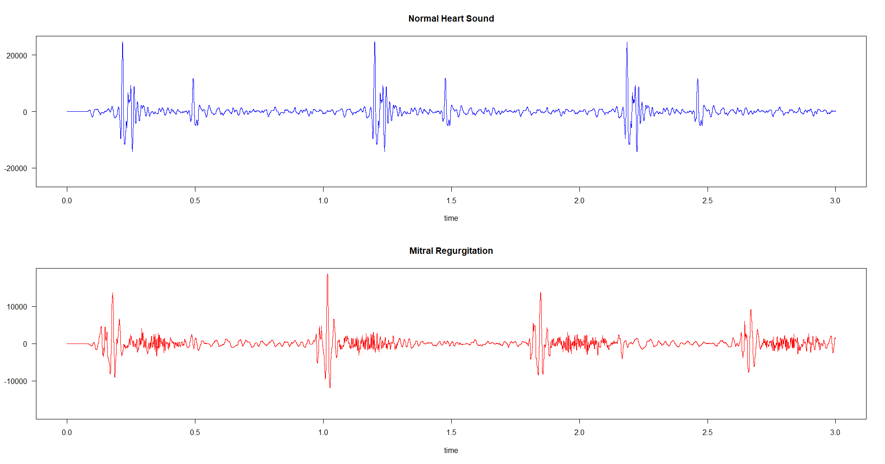

Figure 1 Wave Plot of Heart Sounds

Figure 1 compares normal and mitral regurgitation (MR) heart sounds over 3 seconds. The waveforms reveal distinct temporal and morphological differences characteristic of pathological valvular dysfunction. The upper panel represents a normal heart sound; each cardiac cycle is marked by two prominent sound waves corresponding to the first (S1) and second (S2) heart sounds. These sounds are separated by a period of brief silence, indicating the absence of turbulent flow during systole. The sharp amplitude suggests efficient physiology of valve closure with normal hemodynamic flow within heart chambers.

This contrasts with the bottom panel, which illustrates the typical mitral regurgitation heart sound, marked by an initial S1 but indiscernible S2 peak. A continuous low-amplitude acoustic activity occupies the segment typically filled with silence from the laminar blood flow. The persistent signal corresponds to a pansystolic murmur, a hallmark of mitral regurgitation caused by the retrograde blood flow from the left ventricle to the left atrium during systole, often caused by valvular dysfunction. The waveform analysis shows effective differentiation between normal and pathological heart sounds.

* + 1. Timer Analysis

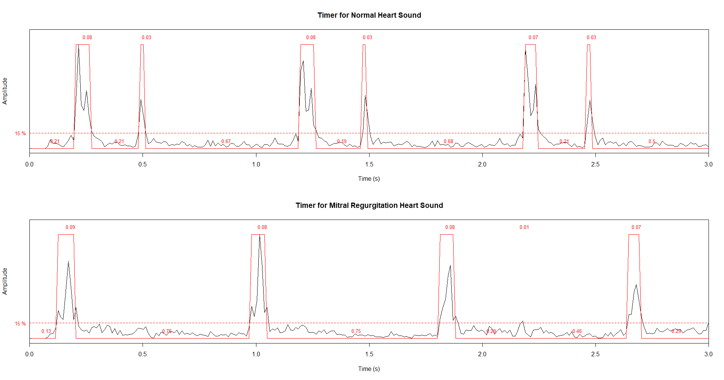

Figure 2 Timer Plot of Heart Sounds

Complementing the waveform comparison, the timer plots in Figure 2 offer quantitative analysis of the temporal structure and duration of the acoustic events in both the normal and MR heart sounds. The plots visualise the signal envelope and highlight segments that pass a defined amplitude threshold (15%), identifying them as sound events.

The timer plot for the normal heart sounds (top panel) shows regular, sharply bounded acoustic events. Each cardiac cycle displays two amplitude outbursts, S1 and S2, with short durations, 0.08 and 0.03 seconds, respectively. Each cardiac cycle is followed by well-defined intervals of 0.67-0.68 seconds. This regular alternating effect reflects normal cardiac physiology, with efficient valvular mechanisms highlighted by the consistency in timing and separation.

Conversely, the MR timer plot (bottom panel) exhibits prolonged low-amplitude activity between the main peaks, indicating possible underlying pathology during systole. While S1 is still present, S2 appears barely discernible with noisier inter-sound intervals extending over longer durations of 0.75 between S1s. This reflects the presence of pansystolic murmur, consistent with the pathophysiological features of mitral regurgitation.

These timer plots reinforce the distinction between normal and pathological heart sounds by quantifying temporal events and providing an objective measure of murmur.

* + 1. Frequency Analysis

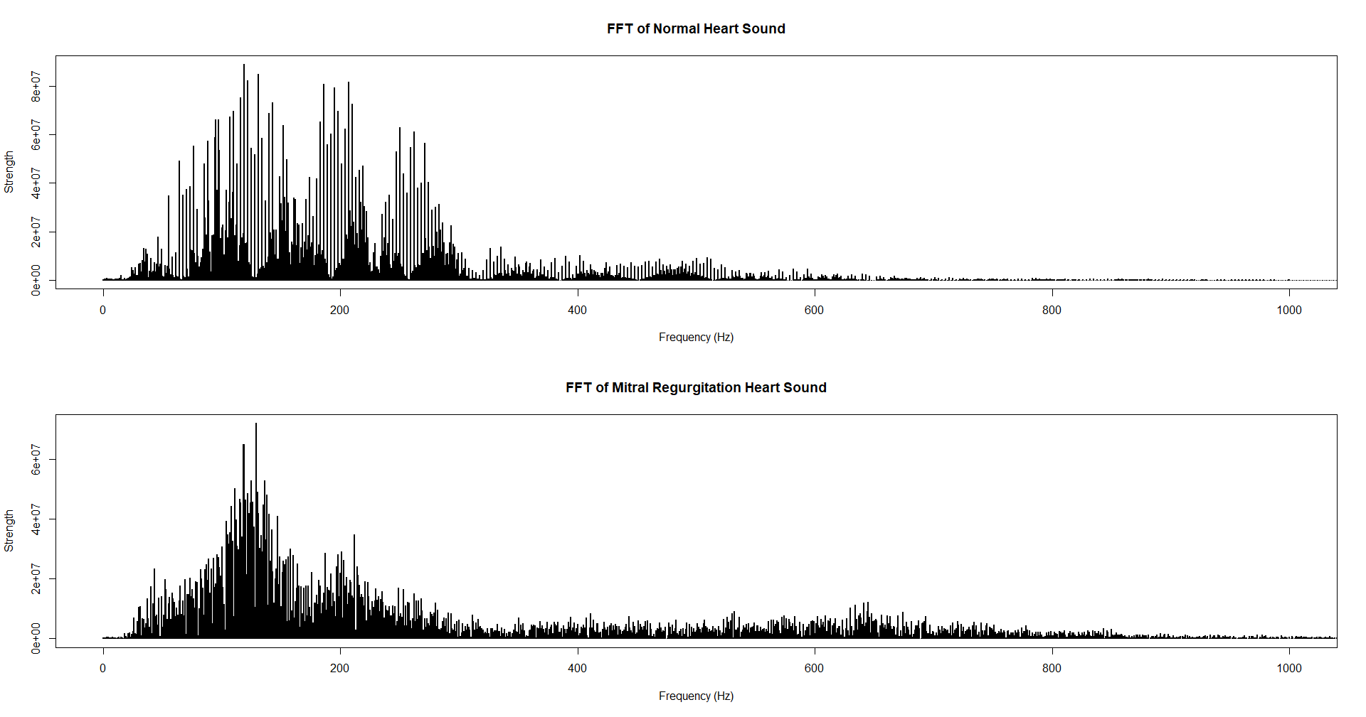

Figure 3 Fast Fourier Transform of Heart Sounds

To further elucidate the spectral characteristics of heart sounds, the Fast Fourier Transform (FFT) plots in Figure 3 provide insight into the frequency-domain distribution of acoustic energy in both normal and MR signals. The FFT quantifies the signal strength across a range of frequencies, highlighting dominant frequency components.

The normal heart sound spectral energy is concentrated within the 50 – 250 Hz range, with multiple sharp and distinct peaks. This indicates that the majority of the acoustic power is confined towards the lower frequencies reflecting the mechanical closure of heart valves with minimal turbulence. Beyond 300 Hz, the signal strength rapidly declines forming a narrow band of normal heart sound energy.

The FFT of the MR heart sounds shows a broader spectral distribution with energy extending up to 600 Hz. While the peak cluster signals remain at 250 Hz, the energy is more widespread with a less sharp peak. This broader and flatter spectral profile is consistent with the turbulent flow of regurgitant blood during systole, which produces a continuous murmur of complex high-frequency components. Together, these FFT plots reinforce the distinction between the structured, low-frequency characteristics of normal heart sounds and the disorganised, wide-band spectrum of MR.

* + 1. Spectrogram

Figure 4 Spectrogram of Heart Sounds

Building upon the waveform and timer analyses, the spectrograms provide a time-frequency representation of the heart sounds, capturing both the temporal and spectral evolution of acoustic energy. These plots visualize how sound intensity (in dB) is distributed across different frequencies (0–500 Hz) over the 3-second recording window for both normal and mitral regurgitation (MR) heart sounds.

In the normal heart sound spectrogram (top panel), the acoustic energy is concentrated in brief, high-intensity bursts, corresponding to the first (S1) and second (S2) heart sounds. These appear as vertical bands of high amplitude, primarily between 100–200 Hz, and are sharply defined with clear separation in time, reflecting the discrete, non-continuous nature of normal valve closures. Between each S1 and S2, and particularly during diastole, the spectrogram shows minimal activity, indicating the absence of turbulent flow or murmurs.

In contrast, the mitral regurgitation spectrogram (bottom panel) demonstrates a more diffuse and continuous spread of acoustic energy, particularly in the 100–300 Hz range. While the initial peaks associated with S1 and S2 are still visible, they are less sharply defined. More notably, there is persistent low- to mid-frequency energy throughout systole, filling the gap between S1 and S2. This sustained energy corresponds to the pansystolic murmur caused by backflow of blood through the incompetent mitral valve, and its spectral pattern is less discrete and more smeared than in the normal case.

Together, these spectrograms reinforce the diagnostic difference between normal and pathological heart sounds. The discrete, rhythmic patterns of the normal heart are replaced in mitral regurgitation by spectrally dispersed, continuous energy patterns, highlighting the utility of time-frequency analysis in identifying and characterizing murmurs.

* 1. Discussion
     1. Comparison of Heart Sound Features

The analysis clearly highlights the distinction between normal heart sounds and those with mitral regurgitation (MR), consistent with prior literature. In the temporal domain, the normal heart phenocardiogram (PCG) shows two discrete sounds (S1 and S2) separated by silent intervals (systole and diastole). This is in contrast to the MR recording which exhibits a prolonged continuous sound (murmur) filling the systolic interval between S1 and S2 (Akbari et al. 2011). This corresponds to the holosystic murmur of MR which spans from S1 to S2 (Chambi et al. 2024).

Spectral analysis further evaluates these differences. The normal S1 and S2 are low-frequency, transient events. Studies have shown that S1 and S2 concentrate on lower frequencies of 20 Hz to 200 Hz (Debbal 2020; Padilla-Ortiz & Ibarra 2018). Noor and Shadi (2013) found that peak frequencies in heart sounds appear to be around 180 Hz, which is similar to our findings. Thus, S1 and S2 appear in 2 distinct bursts of energy, primarily in the lower frequency band. However, normal heart sound should appear “flat” during the systole period (between S1 and S2) (Akbari et al. 2011).

In contrast, MR produces a broad, noise-like spectral signature during systole. Our findings showed that MR murmur’s frequency content is spread across a wider range, extending into mid-higher frequencies. This aligns with murmur features, which are high-frequency, noise-like sounds caused by turbulent flow from the reflow of atrioventricular valves, pathognomonic for MR (Safara et al. 2013). Our findings also concur with Akbari et al. (2011) where the systolic murmur contains frequencies extending to 400 Hz, this broadband nature of sound is to be expected due to the turbulence from regurgitant flow, generating a wide spectrum of frequencies, unlike the more systematic periodic valvular closures. Our study using Fast Fourier Transform (FFT) also aligns with these findings.

However, the limitation of FFT is that it ignores timings and assumes that audio signals are stationary. That is not the case for cardiac cycles; time-frequency analysis is essential. Utilising methods such as the Short-Time Fourier Transform (Spectrogram), this study can localise the exact MR murmur’s broad frequency in relation to the systolic period, which is not available in simple FFT (Debbal 2020). This study builds on this by clearly differentiating the temporal occurrence of normal heart sounds vs MR murmurs.

Other recent works using spectrogram have noted visual differences between normal and regurgitant heart sounds that match our observations such as Chambi et al. (2024) that report anomalous high-frequency band due to retrograde flow caused by MR. Safara et al. (2013) and Akbari et al. (2011) note that murmurs (specifically MR) contain noisy, high-frequency sounds in contrast to the more periodic nature of normal physiological tones. Our findings mirror these descriptions as well. In summary, the frequency ranges and duration of MR mumur observed in our analysis are well supported by prior literature. Normal S1-S2 sounds are short low-frequency bursts, whereas MR is a prolonged, broadband signal that extends into higher frequencies. By comparing waveform, FFT, and spectrogram results, we not only confirmed known differences, but also highlighted the importance of time-frequency analysis in aligning our observations with established MR signatures.

* 1. Conclusion and Future Works

This study shows how time-domain, frequency-domain, and time-frequency-domain analyses distinguish between normal heart sounds and those impacted by mitral regurgitation. It was feasible to visually and quantitatively differentiate between normal cardiac function and the chaotic, turbulent signals typical of MR using waveform plots, timer outputs, FFT, and spectrograms. The MR signal showed continuous, low-amplitude murmur activity between S1 and S2, suggesting the presence of retrograde blood flow during systole. In contrast, the normal heart sound showed clear S1 and S2 events and little activity during systole.

The study was limited by its minimal sample size and dependence on pre-recorded, idealised audio data, even though the results confirm the diagnostic potential of these techniques. Future studies could build on this foundation by using a bigger and more varied dataset, such as actual patient recordings from different clinical settings. Furthermore, by using hybrid approaches, integration with machine learning models could automate the detection process while preserving interpretability. Overall, reiterating the importance of straightforward yet efficient signal processing methods in clinical and educational settings, this study advances the expanding field of digital auscultation.

References

Akbari, M. A., Hassani, K., Doyle, J. D., Navidbakhsh, M., Sangargir, M., Bajelani, K. & Ahmadi, Z. S. 2011. Digital Subtraction Phonocardiography (DSP) applied to the detection and characterization of heart murmurs. *Biomed Eng Online* 10: 109.

Chambi, E. M., Cuela, J., Zegarra, M., Sulla, E. & Rendulich, J. 2024. Benchmarking Time-Frequency Representations of Phonocardiogram Signals for Classification of Valvular Heart Diseases Using Deep Features and Machine Learning. *Electronics* 13(15): 2912.

Debbal, S. M. E. A. 2020. Analysis of the four heart sounds statistical study and spectro-temporal characteristics. *Journal of medical engineering & technology* 44(7): 396-410.

Donnerstein, R. L. 1989. Continuous spectral analysis of heart murmurs for evaluating stenotic cardiac lesions. *Am J Cardiol* 64(10): 625-630.

Dornbush, S. & Turnquest, A. 2023. Physiology, Heart sounds, Treasure Island, StatPearls Publishing, FL.

Douedi, S. & Douedi, H. 2024. Mitral regurgitation. In (ed.). *StatPearls [Internet]*: StatPearls Publishing.

Noor, A. M. & Shadi, M. F. 2013. The heart auscultation. From sound to graphical. *Journal of Engineering and Technology (JET)* 4(2): 73-84.

Padilla-Ortiz, A. L. & Ibarra, D. 2018. Lung and heart sounds analysis: state-of-the-art and future trends. *Critical Reviews™ in Biomedical Engineering* 46(1):

Reyna, M. A., Kiarashi, Y., Elola, A., Oliveira, J., Renna, F., Gu, A., Sadr, N., Alday, E. a. P., Sharma, A., Mattos, S. D. S., Coimbra, M., Sameni, R., Rad, A. B. & Clifford, G. 2022. Heart Murmur Detection From Phonocardiogram Recordings: The George B. Moody PhysioNet Challenge 2022.

Safara, F., Doraisamy, S., Azman, A., Jantan, A. & Ranga, S. 2013. Diagnosis of heart valve disorders through trapezoidal features and hybrid classifier. *International Journal of Bioscience, Biochemistry and Bioinformatics* 3(6): 662.

Singh, J. & Anand, R. S. 2007. Computer aided analysis of phonocardiogram. *J Med Eng Technol* 31(5): 319-323.

Wang, X., Li, Y., Liu, C., Liu, C., Ji, L. & Zeng, H. 2016. Changes in Amplitude Characteristics of Heart Sound Signals During External:cuff:inflation Procedure: A Pilot Study.

Yazdani, S., Schlatter, S., Atyabi, S. A. & Vésin, J.-M. 2016. Identification of Abnormal Heart Sounds.